MService App Download & Device Id capture handbook
Players: | Service Engineer | Anyone using MService Mobile app

Contents
1. Download 2
2.Type the MService in Search box 2
3.Click MService and Look for the highlighted Logo 3
4. Click Install Button 4
5. Click Accept 5
6. After the download Click Open 6
2. Capture Device id 7
1. Note the Device Id in the Bottom of App 7

1. Download

2.Type the MService in Search box
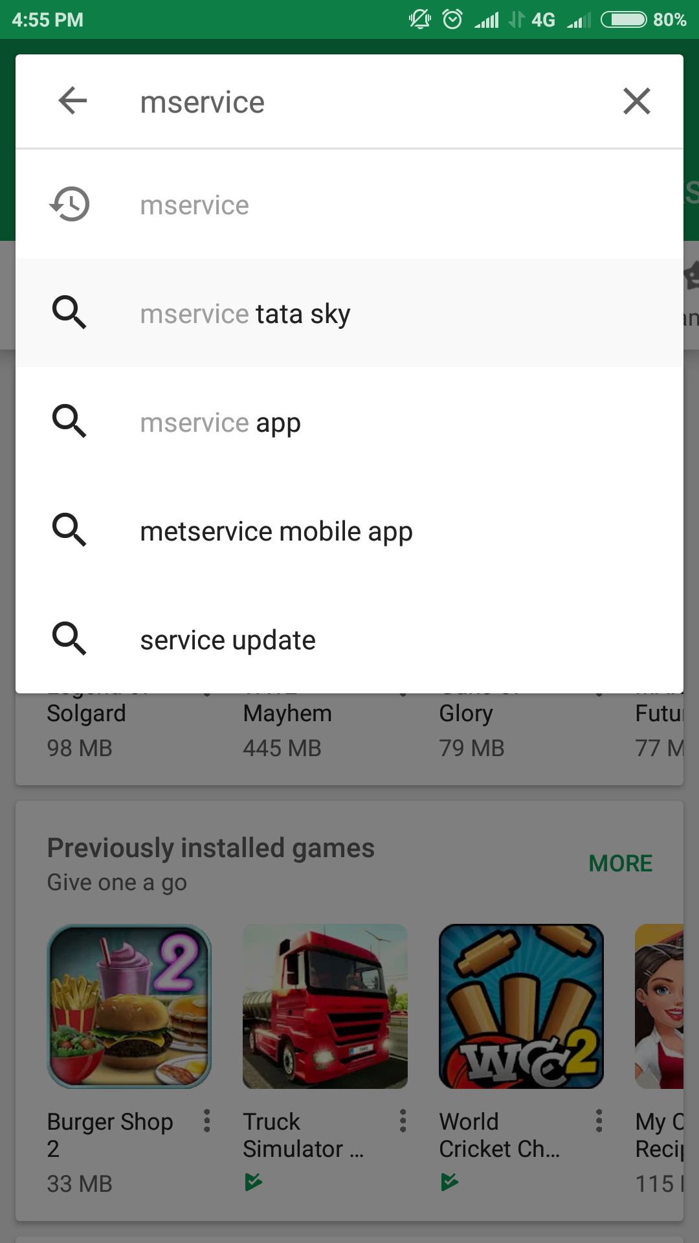

3.Click MService and Look for the highlighted Logo

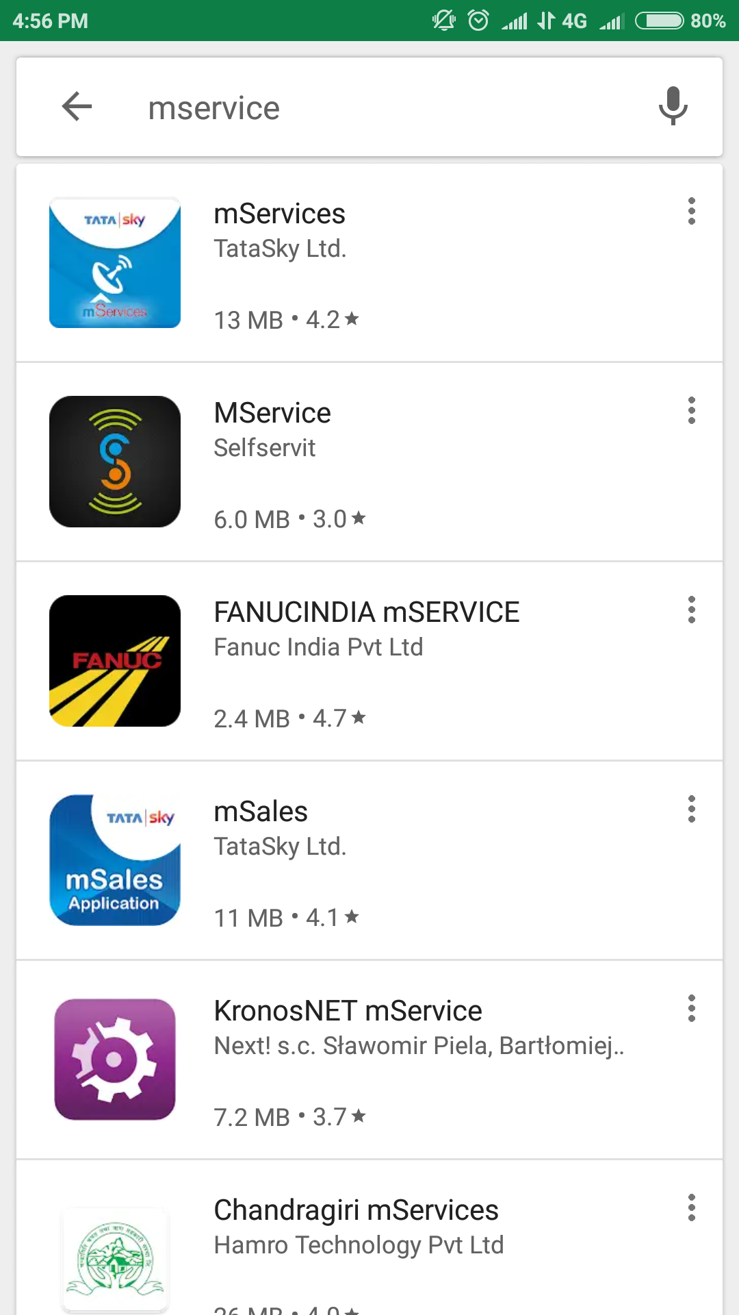

4. Click Install Button
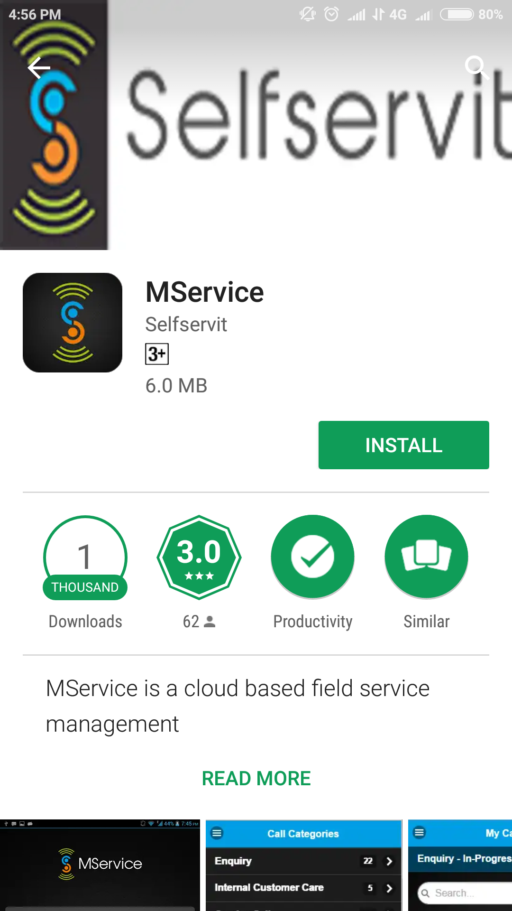

5. Click Accept

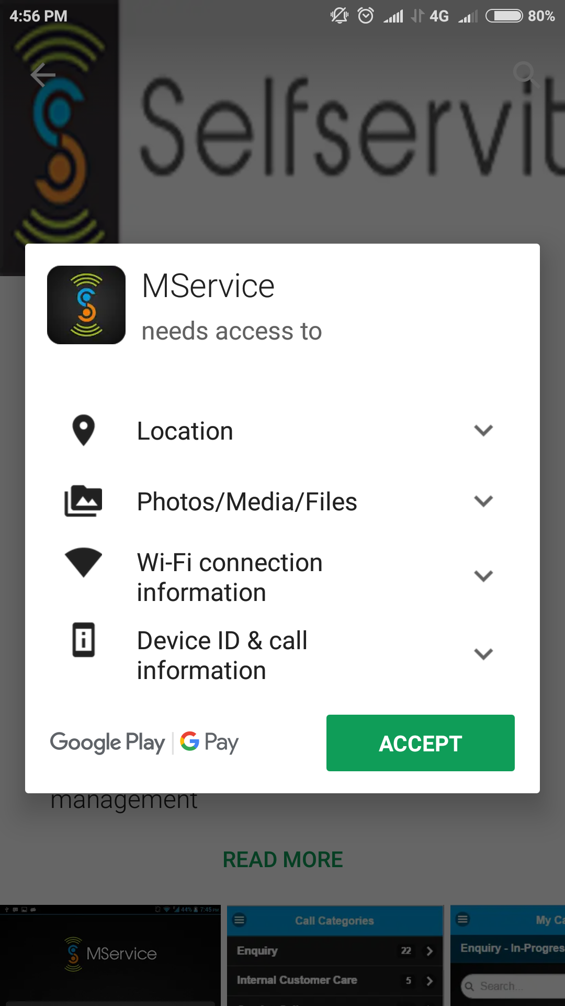

6. After the download Click Open
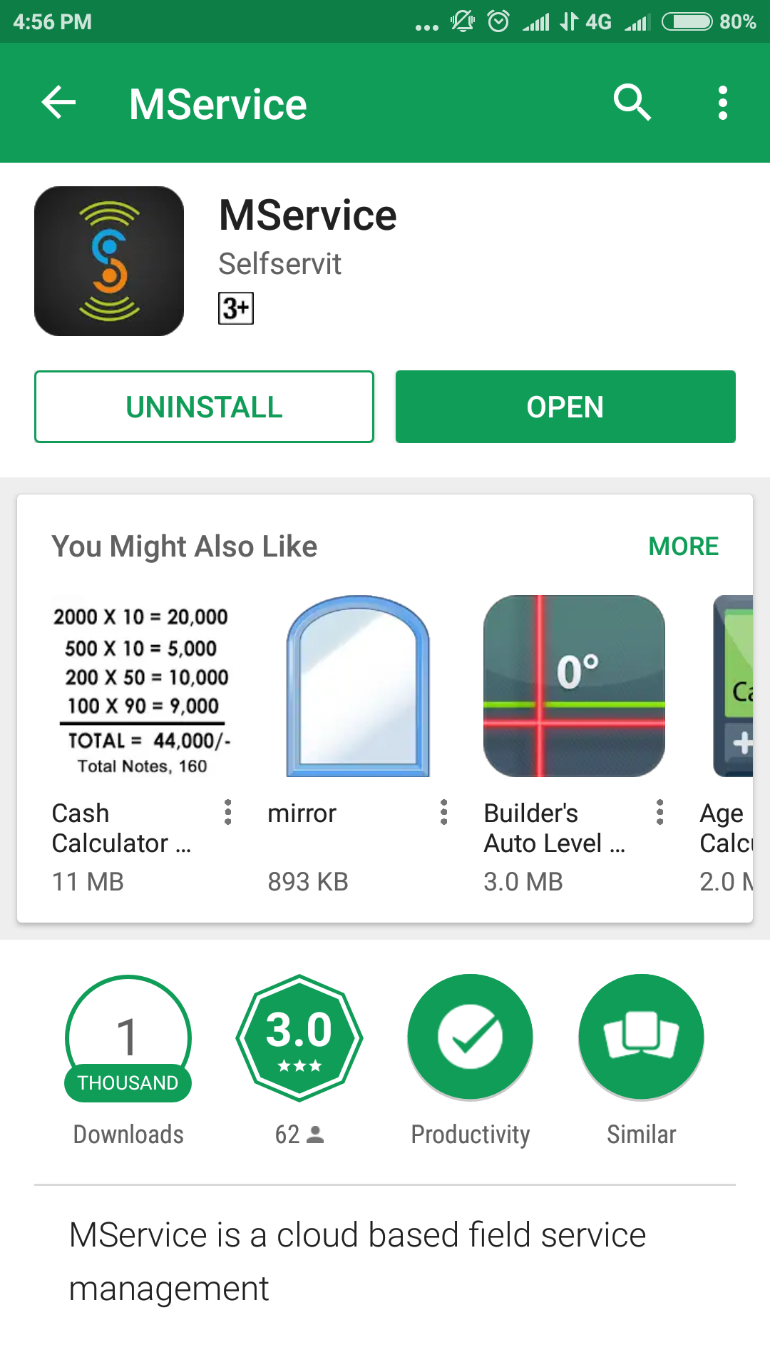

2. Capture Device id

1. Note the Device Id in the Bottom of App

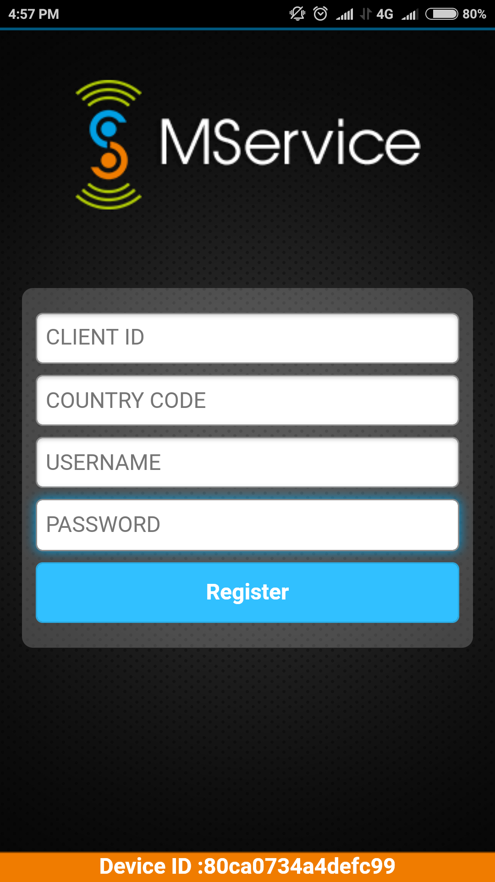

Register Mobile
Please check if the version of MService is Latest (1.9.06)
Please enter the details in lower case
Enter Client id: cpct
Country code : in
User_name : sent to you
Password : welcome

